

SMARTER DISTRIBUTION SYSTEM

System Requirements Specification Document v 1.0

V.SundaraGopal
sundaven@in.ibm.com

Table of Contents:

Introduction 3
Scope: 3
Assumptions 3
Management Summary 3
System Objectives / Overview 4
Figure 1 System Context Diagram 4
Refrences 5
Initial requirement document 5
Common requirements: 5
Message Sequencing Requirements 5
Message Persistence Requirements 5
Message Size Requirements 6
Error & Exception Handling Requirements 6
Auditing/Logging Requirements 6
Functional Requirement 1 – Process the Meter Message 6
Brief Description 6
Interface Details 6
Table of requirement 6
Email template: 7
Database Schema: 8
SQL Script for table creation: 8
Test Cases: 8
Unit Test Cases – SDS 8
Integration Test Cases – SDS 9
NFR – Test cases 9
XML Schema 9
Adhoc Reporting 9
Disclaimer 10
Products to be used: 10
Resource & References: 11

Introduction

Scope:

This document describes the scope of the requirements for the Smarter distribution System (SDS) for ABC Corp. The document details all the high level requirements with intent to validate ABC’s requirements. This document should be used by the Architect and the developers to design the Solution Architecture for the project.
The key system that is involved in the integration is the smarter distribution system(SDS). The integration is enabled by having a message oriented middleware- Websphere MQ.
There are a total of 2 business use cases or interfaces that have to be enabled through the integration. The scope of the project involves the development of these 2 interfaces that will integrate the SDS with the client. The project is to be deployed in the development environment of ABC corp. Eventual deployment into production will be effected to all geographies that use the SDS.

Assumptions

The following are the assumptions for this document
· It is assumed that the EB meters across the country will adhere to the schema provided by the client for generating meter reading messages.

Management Summary

ABC Corp is a Government organization which is involved in supplying electricity to billion homes in a country.
ABC Corp involves 10,000 employees across cities for taking readings from the consumers EB meter, so that the rent for the electricity consumption can be calculated for the consumers. ABC corp is requesting for a smarter solution so that its 10000+ employees involved in taking EB readings can be involved with some other work. These employees are also complaining of the strenuous nature that involves in taking EB reading. There were dog menace also at some places.

ABC Corp is ready to modify the hardware of its EB meter in order to have some messaging engine which can send out a message on first of every month the with consumer ID with the total units consumed to the central EB server. Based on that EB needs SDS which can calculate the rent and consumption charges for that consumer and emails his bill.

System Objectives / Overview

Consumers

SDS
Consumer - EB meter reading reading

Figure 1 System Context Diagram

The diagram above explains the main conceptual elements in the solution and its
relationships with the architecture. The SDS application is responsible for processing the messages that are generated by the EB hardware meter equipment with the consumer.
1st of Every month the EB meter generates the xml message which adheres to the provided schema, and sends the message to a particular queue.
This message is being picked up by the SDS application. The picked up message is then processed by the application for its reading and it generates and email for the consumption charges and sends it out to the consumers email address.

SDS | Core application that’s is to be developed for processing the meter reading messages. This application is also responsible for sending out an email to the respective consumers for the EB charges based on the reading
Consumer EB meter | Each consumer will have an EB meter with an updated hardware which generates message on 1st of every month and sends it out to a destination queue

Refrences:

Initial requirement document –

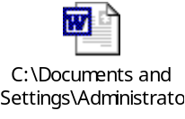

Common requirements:

Message Sequencing Requirements
There are no specific sequencing requirements between any kinds of requests coming
from the meter reading application.

Message Persistence Requirements
All messages that will arrive on WebSphere MQ queues should be persistent.

Message Size Requirements
Each message will be max of 2 KBs. The application will handle any size of the message supported by WebSphere MQ.

Error & Exception Handling Requirements
If an error is encountered in sending email notification, it should retry for 3 times and then log it for manual intervention

Auditing/Logging Requirements
ABC expects all the messages going through the WebSphere MQ to be
audited for future use. This feature should be configurable and there should be options
provided to switch ON and switch OFF auditing. Auditing is expected only for the incoming and outgoing messages only and there is no need for debugging of these messages at runtime. It is required to persist the incoming and outgoing message in a persistent storage system.

Functional Requirement 1 – Process the Meter Message

Brief Description
The SDS should process the incoming message and based on the reading it should generate an email containing the billing details for the respective customers.

Interface Details
Pls see the System Objective diagram.

Table of requirement
Flow | The SDS will pickup the message from the queue and will process the current meter reading sent in the message. It then pulls out the older meter reading that was stored in the DB and calculates the consumption of the electricity for the respective customer. Based on that calculation it arrives at billing of 1 rupees per unit of the reading. For example if for a consumer the current month reading comes to 100 units means then their current month consumption charges is Rs.100. It then generates an email as per the template and sends out an email to the consumer.  For each message the SDS should parse the xml and fetch the client details from DB and generate the current billing details and sends out an email to the respective customer the generated billing details.
Exception Handling | The programmatic exceptions arising out of connections to EIS or MQ needs to be retried for three times and if it fails then it should be raised as errors and logged. The time between the retries is configurable.

Email template:

Dear <Consumer Name>,

Your current monthly reading is <incoming meter reading from the message>. Based on this your current monthly charges is Rs.<calculated amount for that consumer>

Your due date is 15th <running month – running year>.

At your service,
ABC corp.

Database Schema:

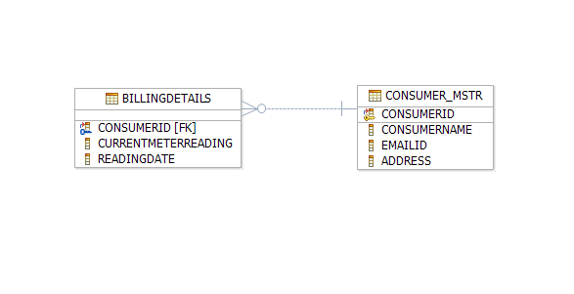

SQL Script for table creation:

This DB scrips were prepared against the derby DB for the above topology.

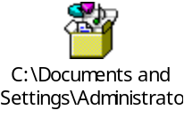

Test Cases:

Unit Test Cases – SDS

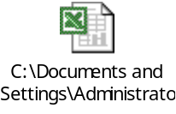

Integration Test Cases – SDS

NFR – Test cases

XML Schema

Schema for meter reading message

Adhoc Reporting

ABC wants a reporting module for the meter reading for a particular customer for a given duration. The screen requirement is as under.

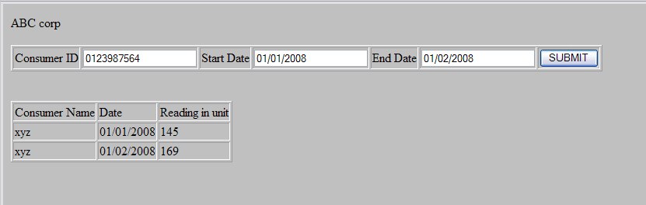

Disclaimer

Most of the DB requirements are captured in the specification. But while developing the solution if the developer has a valid point to add more fields then it can be accommodated after consultation since the DB schema is not freezed as yet.

Products to be used:
Scenario | Product | Description
Developing Use case & UML related activites | IBM Rational Software Modeler, (RSM) | All the UML related specs needs to be developed using RSM only.
Development | IBM Rational Application Developer(RAD) OR WebSphere Integration Developer (WID) | The development of Java/J2EE artifacts should be on RAD or WID only
Database | IBM DB2 V 8.1 or higher | For all the DB requirements, the team should use IBM DB2 only
Team repository | IBM Rational ClearCase | The project team should share there artifacts between them using Rational ClearCase only.
Deployment – Java/J2EE solutions | IBM WebSphere Application Server ND V 6.1 (WAS) | The team should deploy their solutions for testing/production on WAS ND V6.1 only. They should be able to configure the server resources that are required for their solution.
Deployment – Message Oriented Middleware | IBM WebSphere MQ V 6.1 | For all the messaging requirements in the solution, the team should use WMQ V6.1 only.

Trademarks

- DB2, IBM, and WebSphere are trademarks or registered trademarks of IBM Corporation in the United States, other countries, or both.
- Windows and Windows NT are registered trademarks of Microsoft Corporation in the United States, other countries, or both.
- Java and all Java-based trademarks and logos are trademarks or registered trademarks of Sun Microsystems, Inc. in the United States, other countries, or both.
- Other company, product, and service names may be trademarks or service marks of others.

IBM copyright and trademark information: http://www.ibm.com/legal/copytrade.phtml
-----------------------------------------------------
Note: Regarding trademarks:

Trademarks Owner
---------- -----
UNIX The Open Group
Intel, Intel Inside logo, MMX, Pentium Intel
Java and Java-related terms Sun (Use ™ , not ® for Java)
Microsoft, Windows, Windows NT, Windows Logo Microsoft
Linux Linus Torvalds

Resource & References:
- WebSphere MQ on DeveloperWorks- http://www.ibm.com/developerworks/websphere/zones/businessintegration/wmq.html
- WebSphere Application Server on DeveloperWorks- http://www.ibm.com/developerworks/websphere/zones/was/
- Rational Application Developer for WebSphere Software- http://www.ibm.com/developerworks/rational/products/rad/
- Rational Modeler- http://www.ibm.com/developerworks/rational/products/modeler/
- Rational ClearCase- http://www.ibm.com/developerworks/rational/products/clearcase/
- WebSphere Integration Developer- http://www.ibm.com/developerworks/websphere/zones/businessintegration/wps/wps.html
- IBM DB2- http://www.ibm.com/developerworks/data/products/db2/index.html?S_TACT=105AGX11&S_CMP=FP
- IBM RedBooks- http://www.redbooks.ibm.com/

